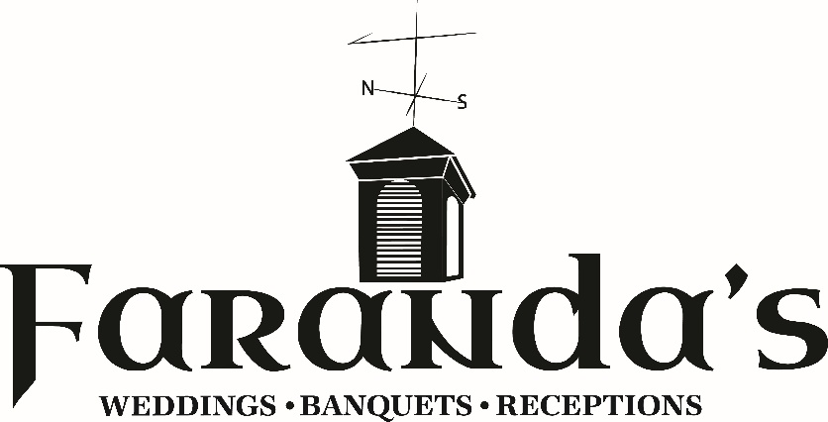

Catering & Event Sales Coordinator
Reports to: Sales & Marketing Director
Position Mission: The Sales & Hospitality Architect
At Faranda’s, we create community through food and hospitality. The Catering & Event Sales Coordinator serves as the proactive engine of our growth - a high-level hybrid of a salesperson seeking new opportunities and a hospitality professional dedicated to providing every client with total peace of mind.
This role owns the relationship and the vision with the customer, acting as the primary architect who bridges the gap between the client’s dream and the staff’s execution. The coordinator is responsible for translating that vision into the precise data the kitchen and service teams need to perform at an elite level. By successfully managing the relationships from the initial tour through the post-event follow-up, this position serves as the Face of Faranda’s and is the primary driver in growing our loyal, repeat customer base.

Roles & Responsibilities
- Sales Pipeline & Client Acquisition: Respond to all inquiries (walk-in, email, and phone) and execute the 45-day outreach and prospecting system to generate qualified leads and opportunities.
- Event Consulting & Design: Lead the client intake and menu selection process, confirming all event details including floor plans, timelines, and mealtimes.
- BEO & Financial Accuracy: Create complete and accurate Banquet Event Orders (BEOs) and invoices; record payments and ensure all financial transactions are documented in company software.
- Service Handoff & Event Transition: Ensure a smooth transition of event details to the event team or catering delivery team, including on-site greetings when required to assure the host that every detail is prepared as promised.
- Relationship Stewardship: Own the post-event follow-up, including thank-you communications and "Next Date" re-bookings to drive repeat business and referrals.
Transparency & Support: The Sales Accountability System
We believe in rewarding high performers who follow our proven sales process. You will always know exactly where you stand regarding your goals and your paycheck.
- Weekly 1-on-1 Coaching: You will meet weekly with leadership to review your scorecard, remove obstacles, and ensure you are on track for your bonuses.
- Activity-Based Eligibility: Bonuses are paid based on two factors: Results (the sales you close) and Process (maintaining 100% completion on your outreach and follow-up logs).
- Clear Metrics: We use a transparent tracking system for sales activities, so you have full control over your bonus eligibility.
Compensation & Performance Incentives
This track is designed for future leaders who want skin in the game and a clear path to high-impact earnings.
- Annual Base Salary: $42,217 – $48,152 (depending on experience).
- Individual Sales Bonus: 2% Uncapped monthly commission on all "New Business" revenue you personally identify and close.
- Account Growth Bonus: 1% "Spiff" paid bi-weekly on the net incremental growth of your assigned managed account portfolio.
- Quarterly Venue Target Bonus: This bonus recognizes the coordinator’s role in driving overall success. It is earned when the company as a whole—encompassing all catering, events, and restaurant operations—achieves its total budgeted revenue targets. Payouts are weighted to reflect the seasonality of the hospitality business.
- Total Projected OTE (On-Target Earnings): $52,000 – $58,000+.
  - Note: OTE projections are based on hitting facility-wide 2026 revenue goals and executing the Faranda's Sales Process.
Schedule & Operational Flexibility
- Commitment: 48 hours per week, Monday – Saturday.
- The Saturday Rule: We manage hours through a "Weekly Bucket." We do not expect you to "guard the office" on Saturdays if your hours were utilized during the week for tours, Chamber events, or late-night meetings.
- Saturday Focus: Saturdays are reserved for venue tours and event hand-offs. Once greets are handled, remaining "bucket hours" are used for proactive sales work for the following week.

Job Requirements & Core Values
To be successful at Faranda’s, you must demonstrate our core values in every interaction:
- Humble: Be willing to help and serve others, embracing new ideas and feedback with a grateful and appreciative spirit.
- Hard Working: Be determined and dependable, with a commitment to getting the job done efficiently and tenaciously.
- Pride in Work: Be committed to delivering a high-quality product by paying consistent attention to every detail in our food, facilities, and service.
- Positive Attitude: Approach work with an upbeat and optimistic mindset, finding ways to have fun and enjoy the process while serving our guests and each other.
- Helpful: Embrace Cooperation & Team Work. Be willing to assist a co-worker or a customer to ensure a successful outcome for everyone involved.

Additional Benefits
- Simple IRA: Dollar-for-dollar company match up to 3%.
- Paid Vacation: 1 week in Year 1; 2 weeks in Year 2+.
- Dining Perks: Includes shift meals during event execution and Friends & Family discounts for personal dining.

